# SQL Server 2019 Express Installation

MS SQL Server Express 2019 is a free version of Microsoft’s SQL Server relational database management system used to develop databases and SQL queries, manipulate data, and perform database-related tasks that do not require large volumes of database storage. We are going to install SQL Server 2019 Express Edition on Windows Server 2019.

* **Step 1: Before we begin, head over to the** [**https://www.microsoft.com/en-us/sql-**](https://www.microsoft.com/en-us/sql-server/sql-server-downloads)[**server/sql-server-downloads**](https://www.microsoft.com/en-us/sql-server/sql-server-downloads) **and download SQL Server 2019 Express Edition.**

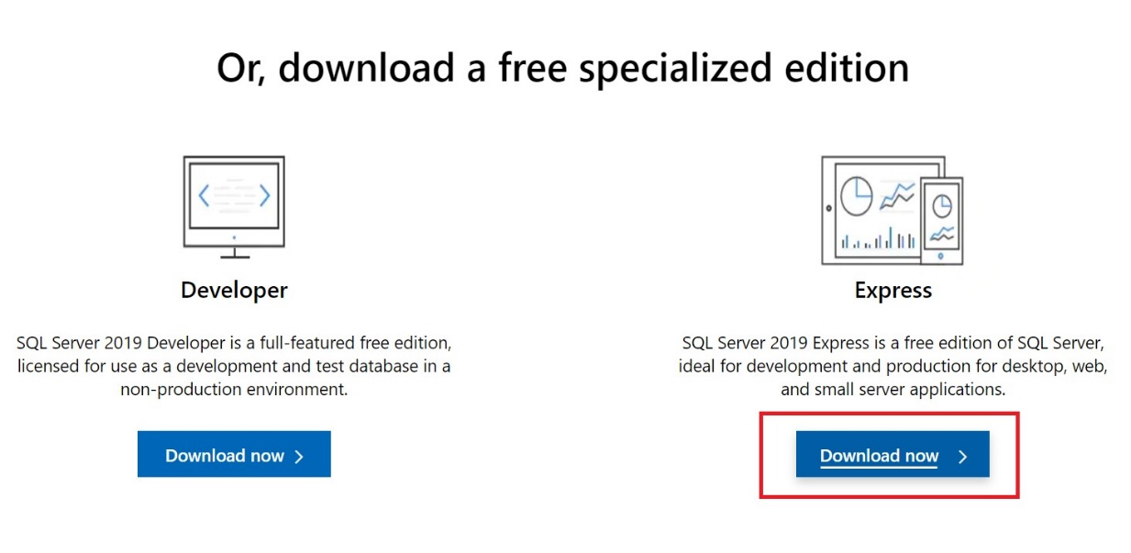

* **Step 2: An .exe file will be downloaded to your system. Double Click that file for further installation.**



* **Step 3: After Double Clicking that .exe file, we have to choose our installation type.**

Let’s start with Basic type as it will install default packages by downloading them from the internet whereas Custom Type provides customized features of SQL Server.

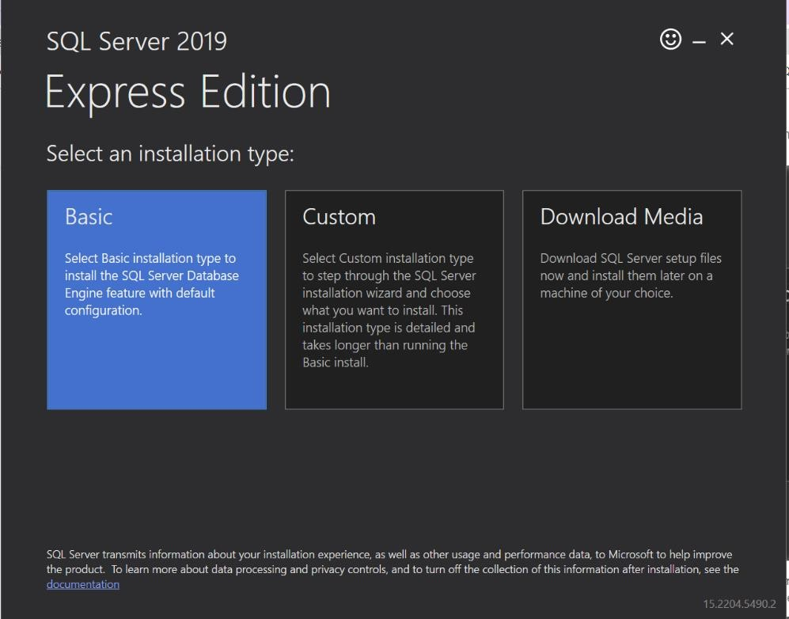

**Step 4: Accept the License Agreement.**

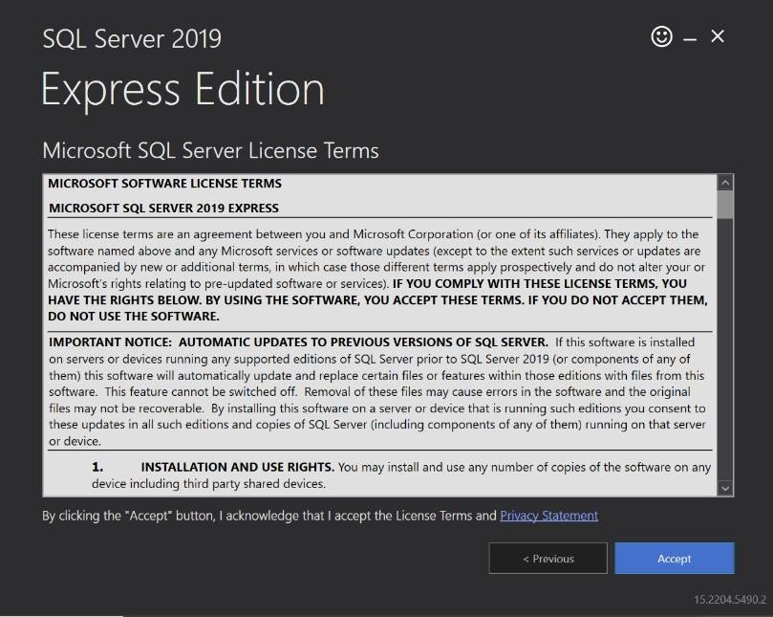

* **Step 5: After that, Specify the location for the install package and click install.**

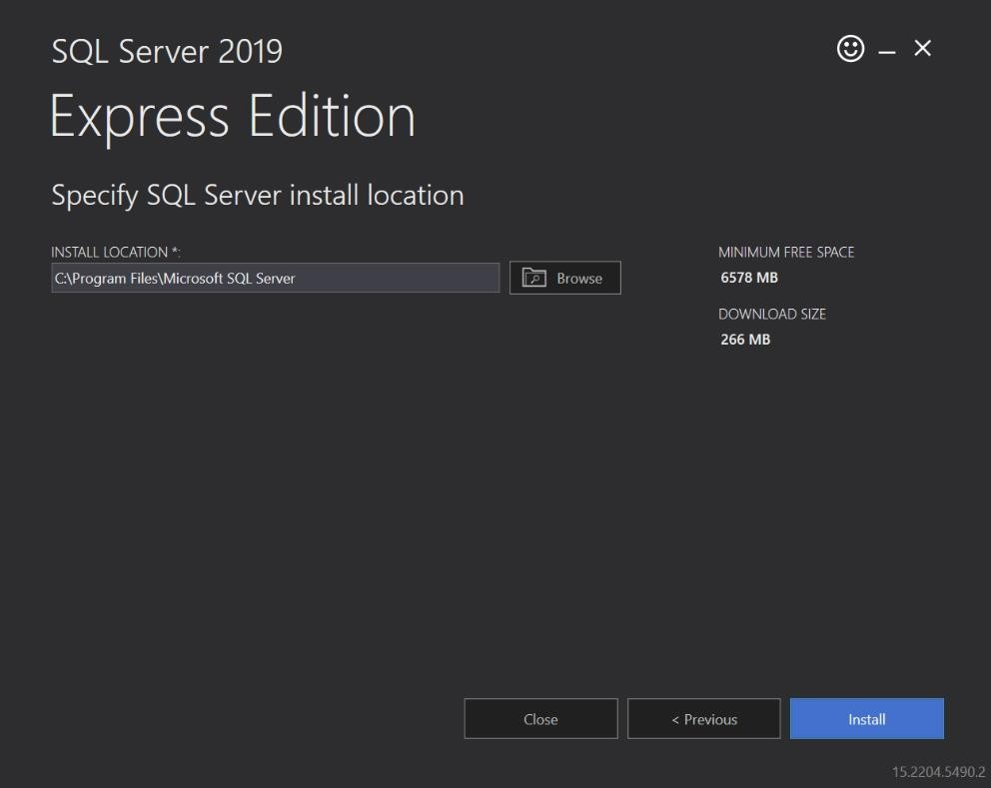

**Step 6: After launching the installation process, you will see a progress bar informing that the install package is being downloaded and that SQL Server Express is being installed.**

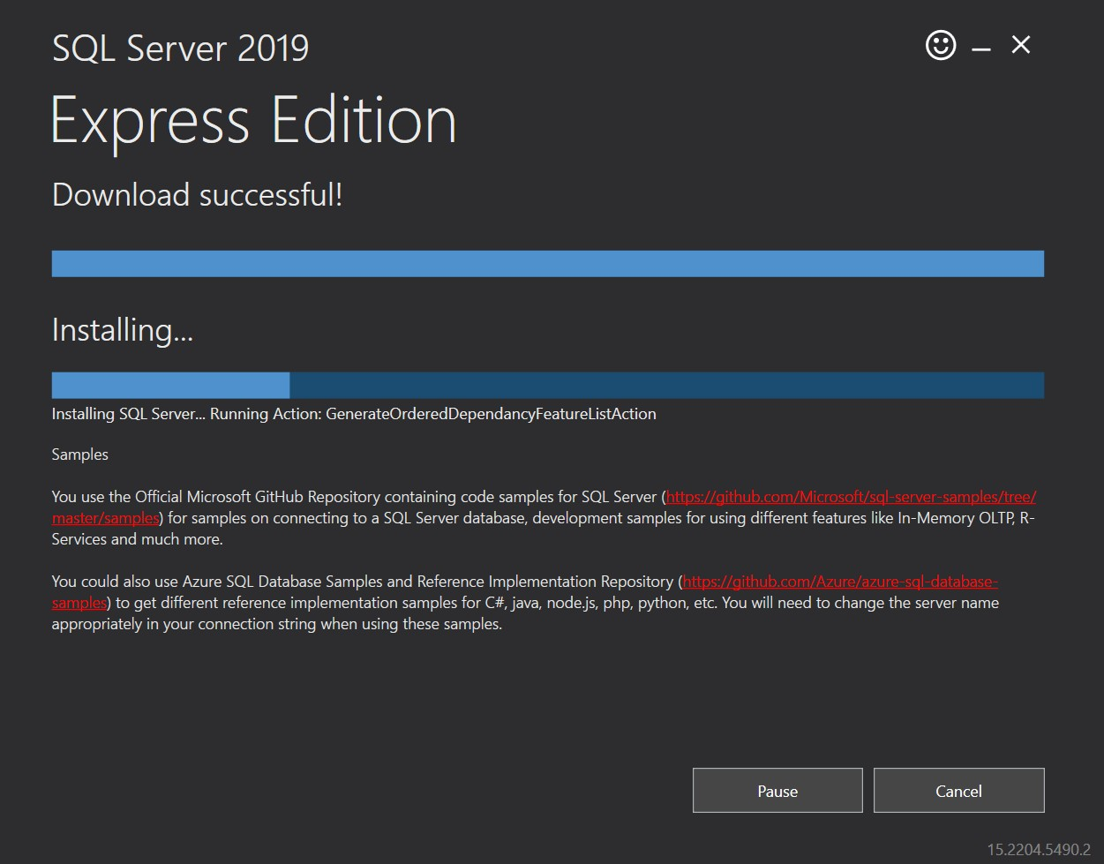

* **Step 7: After the installation has been completed, we can do the following:**
  + Connect to the SQL Server we have just installed via the sqlcmd utility.
  + Launch the SQL Server setup to customize the default configuration for the installation.
  + Install SQL Server Management Studio.
  + Close the installer.

**Let’s customize or modify the configuration of the SQL Server 2019 Express Edition we have just installed.**

* 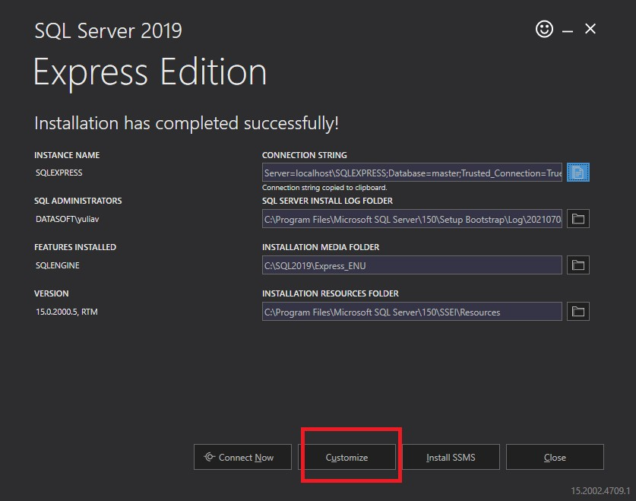**Step 8: The SQL Server 2019 Setup wizard open on the Installation Type tab where you choose either to install a new instance or modify the existing one.**

Here, we are adding features to an existing instance of SQL Server 2019. Click ‘Next’.

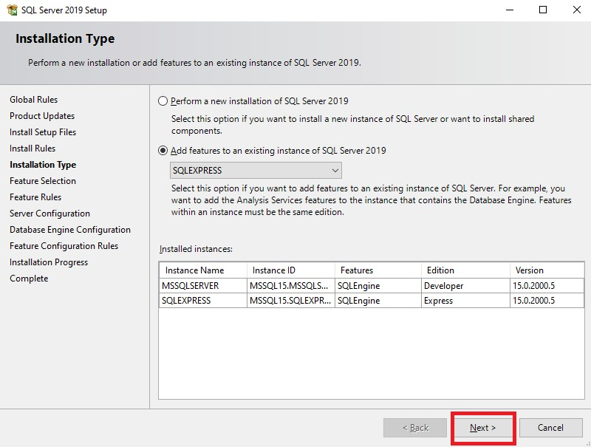

* **Step 9: On the Feature Selection tab, select the instance features to be installed. Click Next.**

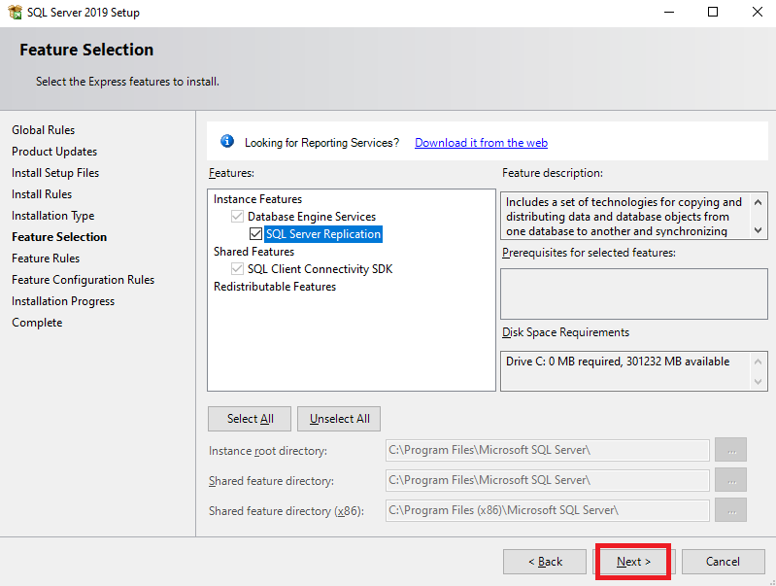

* **Step 10: Following that, the installation starts.**

**After the installation is complete, the Complete tab opens displaying the features installed or failed. In addition, you can view the log file for the feature.**

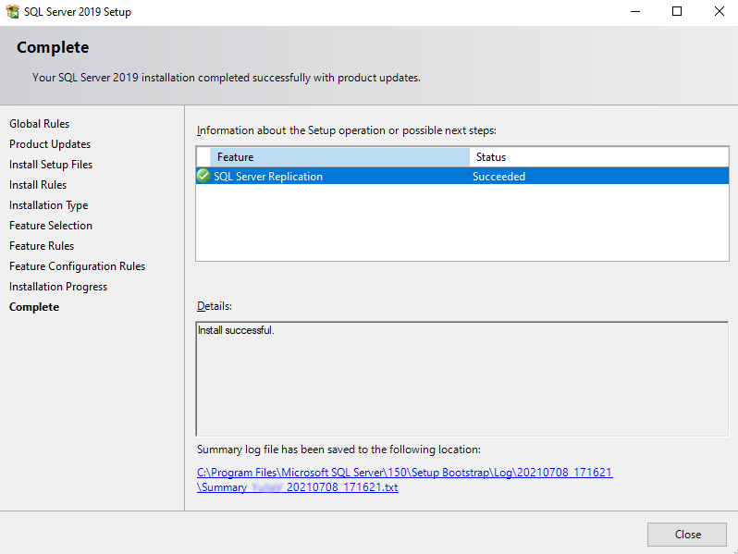

# SQL Server Management Studio (SSMS) Installation

SQL Server Management Studio (SSMS) is an integrated environment for managing any SQL infrastructure. SSMS provides a single comprehensive utility that combines a broad group of graphical tools with many rich script editors to provide access to SQL Server for developers and database administrators of all skill levels.

* + - **Step 1: Download the SQL Server Management Studio -** [**https://docs.microsoft.com/en-**](https://docs.microsoft.com/en-us/sql/ssms/download-sql-server-management-studio-ssms?view=sql-server-ver15)[**us/sql/ssms/download-sql-server-management-studio-ssms?view=sql-server-ver15**](https://docs.microsoft.com/en-us/sql/ssms/download-sql-server-management-studio-ssms?view=sql-server-ver15)

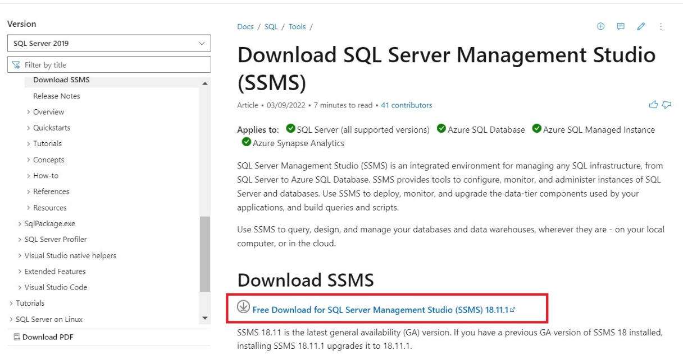

* + - **Step 2: Once the download is complete, go to the downloads folder in your system.** Find the **SSMS-Setup-ENU.exe** and double click to install SSMS.

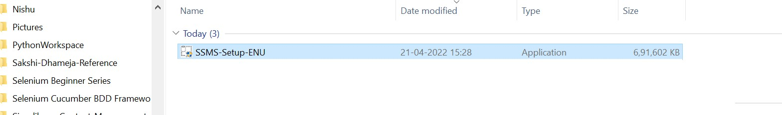

* + - **Step 3: An SSMS (SQL Server Management Studio) installation wizard appear.**

Click on the **Install** button to start installing SSMS. This will take a few minutes to complete installation.

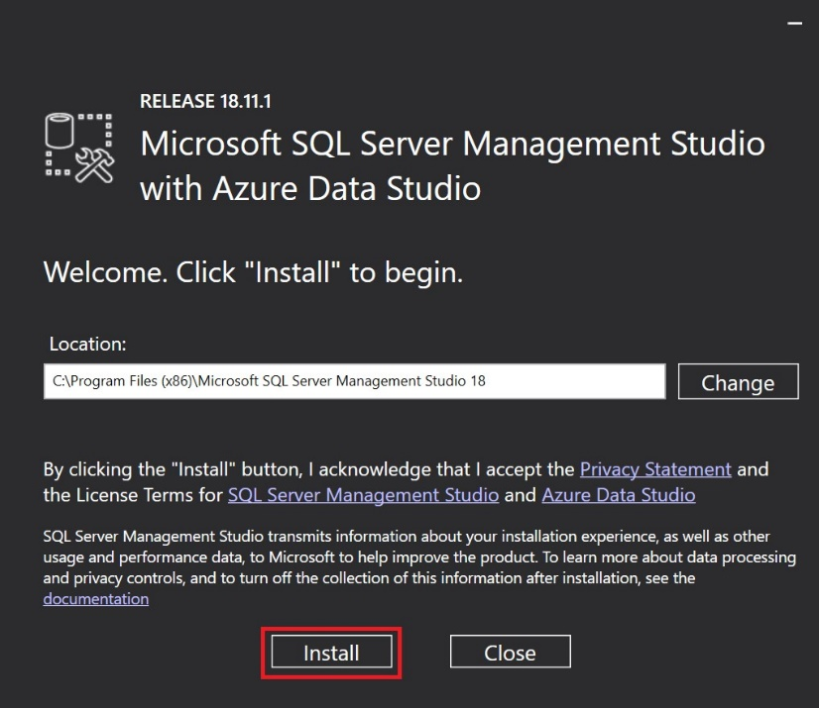

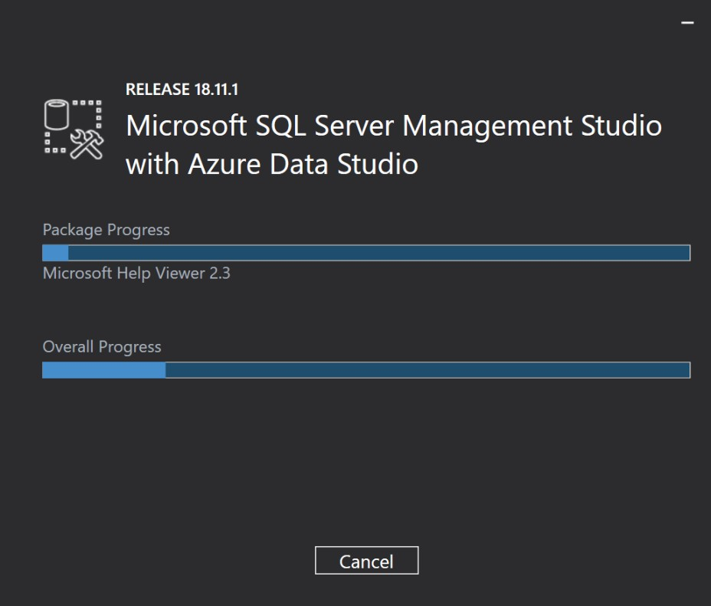

* + - **Step 4: After the completion of Installation, Restart the machine.**

**Finally, SQL Server Management Studio (SSMS) is installed on your Server.**

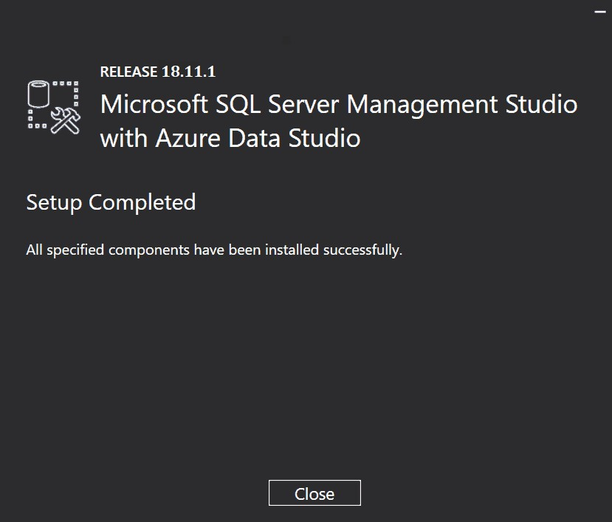

# Change SQL Server to Mixed Role Authentication:

It is considered best practice to configure SQL Server instance to allow only Windows authentication. However, some situations require that SQL Server authentication be used. There are two methods to change SQL Server to mixed mode authentication after installation.

**Step 1: Enable Mixed Mode Authentication in Management Studio.**

As long as you can connect to SQL Server with Windows authentication, you can enable mixed- mode authentication easily using SQL Server Management Studio.

1. Login into SQL Server with SQL Server Management Studio.
2. In Object Explorer, right-click the name of the server that you wish to reconfigure and select Properties from the menu that appears.

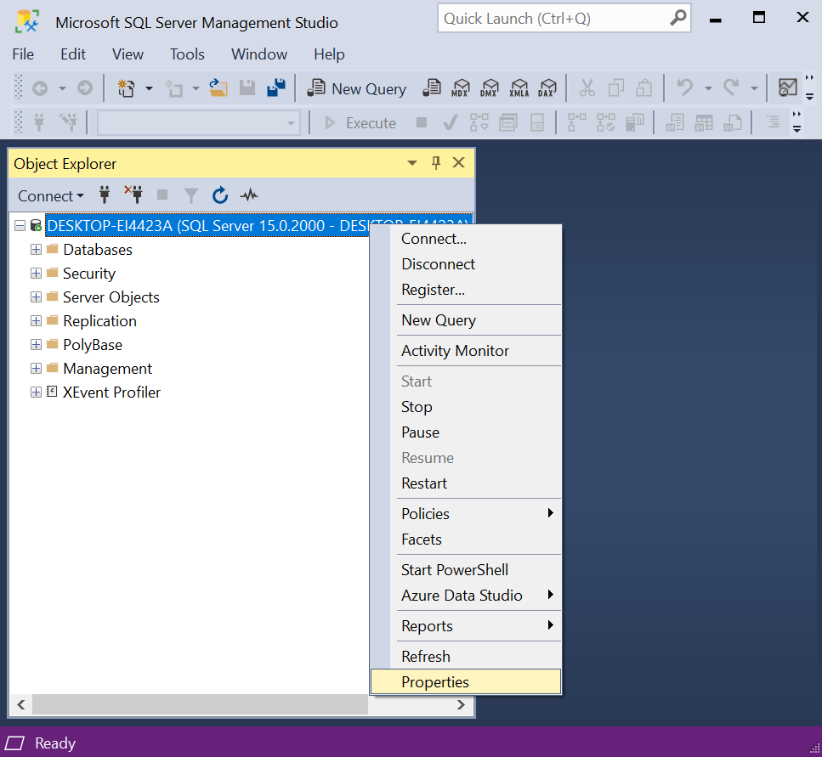

1. This displays the Server Properties dialog box. Select the Security tab and you can then choose SQL Server and Windows Authentication mode (also known as mixed

mode authentication).

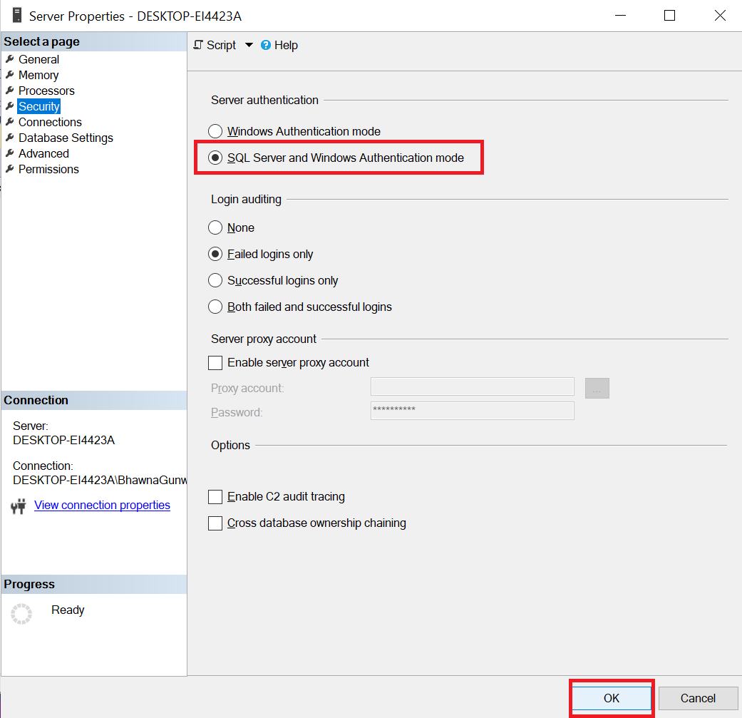

1. Click OK to save the changes and restart the SQL Server service.

**Step 2: To Connect with Windows Authentication Mode:**

1. Go to the File.
2. Click on “Connect Object Explorer”.
3. Server name will be your System Name. If you don’t get it, you can browse for more.
4. By default, Windows Authentication is selected. Then, just Click on **Connect**.

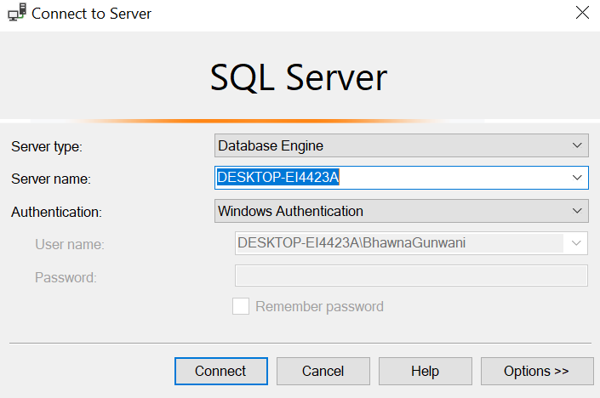

**Step 3: To Connect with SQL Server Authentication Mode:**

1. Go to the File.
2. Click on ‘Connect Object Explorer’.
3. From the Authentication drop-down menu, Select SQL Server Authentication.
4. By default, Login name will be **sa** (System Admin).
5. Password will remain same that you’ve entered while installing SQL Server.
6. Click on **Connect**.

